**Ideation Phase**

**Brainstorm & Idea Prioritization Template**

|  |  |
| --- | --- |
| Date | 15 June 2025 |
| Team ID | LTVIP2025TMID43747 |
| Project Name | Traffic Telligence Advanced Traffic Volume Estimation With Machine Learning |
| Maximum Marks | 4 Marks |

**Brainstorm & Idea Prioritization Template:**

Brainstorming provides a free and open environment that encourages everyone within a team to participate in the creative thinking process that leads to problem solving. Prioritizing volume over value, out-of-the-box ideas are welcome and built upon, and all participants are encouraged to collaborate, helping each other develop a rich amount of creative solutions.

Use this template in your own brainstorming sessions so your team can unleash their imagination and start shaping concepts even if you're not sitting in the same room.

Reference: <https://www.mural.co/templates/brainstorm-and-idea-prioritization>

**Step-1: Team Gathering, Collaboration and Select the Problem Statement**

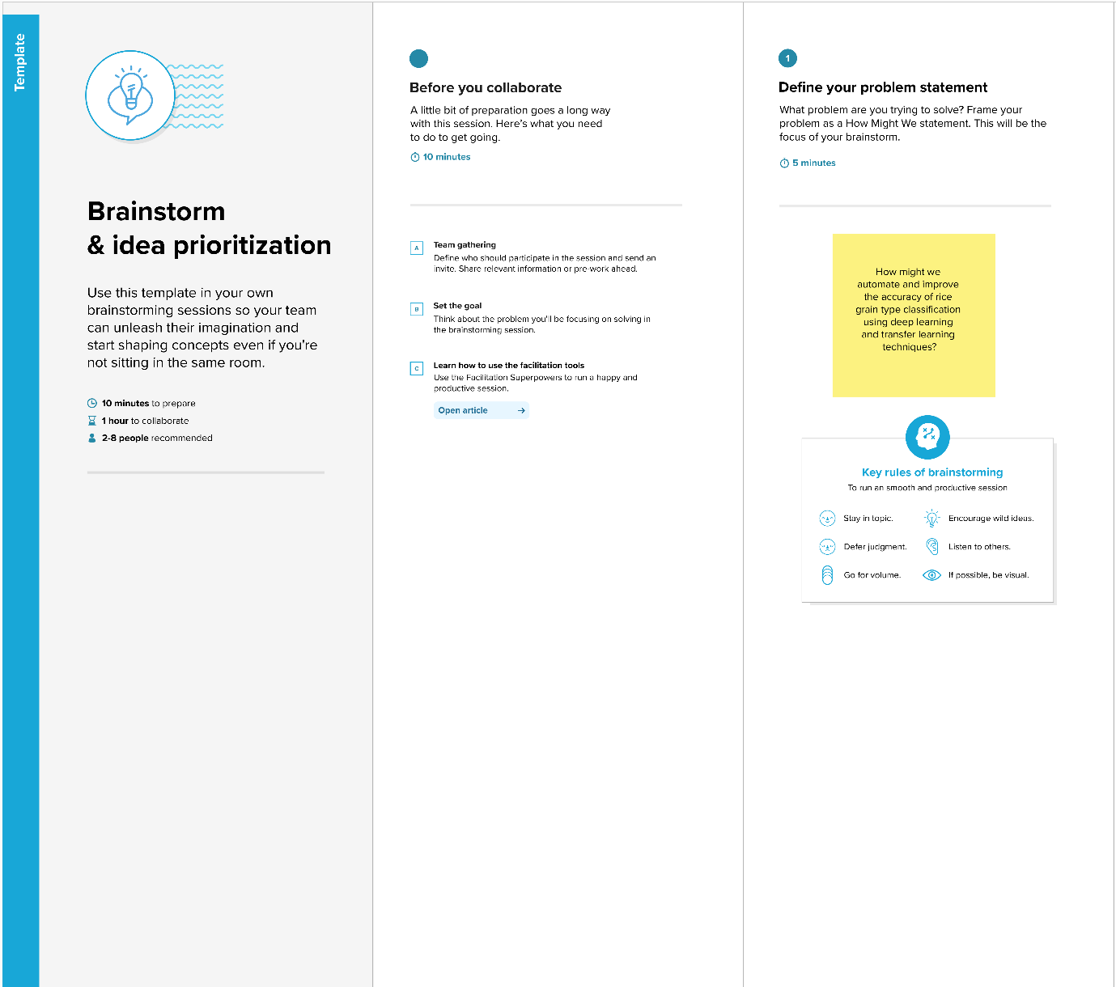

**Step-2: Brainstorm, Idea Listing and Grou**

Shilpa

Kavya

Chaithanya

Jitendra



Study traffic systems, gather existing solutions, define problem scope

Analyze patterns, train ML models (e.g., congestion prediction, accident hotspots)

The technologies/tools involved (e.g., sensors, cameras, Python, ML, GIS)

The project's goals (e.g., reduce congestion, improve traffic flow, monitor violations)

Create graphs, charts, final report, and presentation materials

Test all modules (data accuracy, app functions), find and fix issues

Build dashboard/app (frontend + backend), integrate real-time monitoring tools

Analyze patterns, train ML models (e.g., congestion prediction, accident hotspots)

Filter, clean, and prepare the collected data for analysis

Deploy sensors/cameras, collect live traffic data (vehicle count, speed, etc.)

Study traffic systems, gather existing solutions, define problem scope

**Step-3: Idea Prioritization**

